**SOCIETY ENTRY MANAGEMENT SYSTEM**



Session: 2025 – 2029

**Submitted by:**

Your Name: Faizan Shakeel Your Registration No: 2025S-CS-09

**Supervised by:**

Sir Laeeq

Department of Computer Science

**University of Engineering and Technology**

**Lahore Pakistan**

**SHORT DISCRIPTION:**

The Society Entry Management System records and manages visitor entries and exits in a residential society. It supports role-based access for Admins, Gatekeepers, and Members. The system ensures secure visitor tracking, allows member guest approvals, and provides real-time data on who is currently inside.

**USER OF APPLICATION:**

The Society Entry Management System is designed with a role-based structure to ensure secure and efficient use.

* **Admin** (holds the highest level of access, allowing them to manage users, view and sort all visitor entries, and maintain system integrity).
* **Gatekeeper** (is responsible for recording visitor entries and exits, and for monitoring daily visitor statistics).
* **Member** (has access to view their personal visitor history, see visitors currently, view today’s overall entries and pre-approve expected guests for smoother entry).

**FUNCTION REQUIREMENTS:**

1. **User Authentication**

* The system shall allow users to log in using a username and password.
* Users shall be assigned roles: ADMIN, GATEKEEPER, MEMBER.

1. **User Role Management**

* ADMIN can add new users and assign roles.
* ADMIN can change their password.

1. **Visitor Entry Management**

* ADMIN and GATEKEEPER can add new visitor entries with details such as name, contact number, reference, entry time, day, vehicle type, place, and vehicle number.
* Visitors’ details are saved persistently to file storage.

1. **Visitor Records Viewing**

* Users can view visitor entries filtered by day or all records.
* MEMBERS can view their own visitor history and visitors currently inside.

1. **Visitor Search and Edit**
   * Users can search for visitor entries by name.
   * ADMIN can edit or delete visitor records.
2. **Data Sorting**
   * ADMIN can sort visitor records by visitor name.
3. **Statistics**
   * ADMIN can view statistics such as total visitors, vehicle type counts, time of entry distribution, and day-wise entries.
4. **Pre-Approval of Visitors**
   * MEMBERS can pre-approve visitors before their entry.
5. **Entry Counts**
   * GATEKEEPER can count and view the number of visitor entries for a given day.
6. **File Handling**
   * The system loads users and visitor data from files at startup and saves data back to files after modifications.

**WIREFRAMES**

**DATA STRUCTURE:**

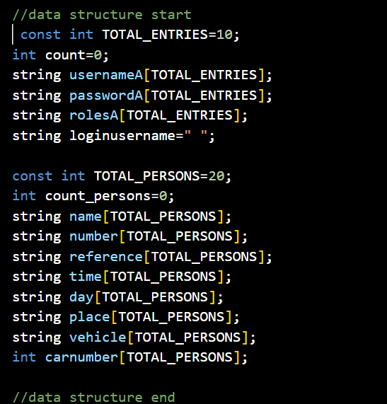

1.data structures

**FUNCTION PROTOTYPES:**

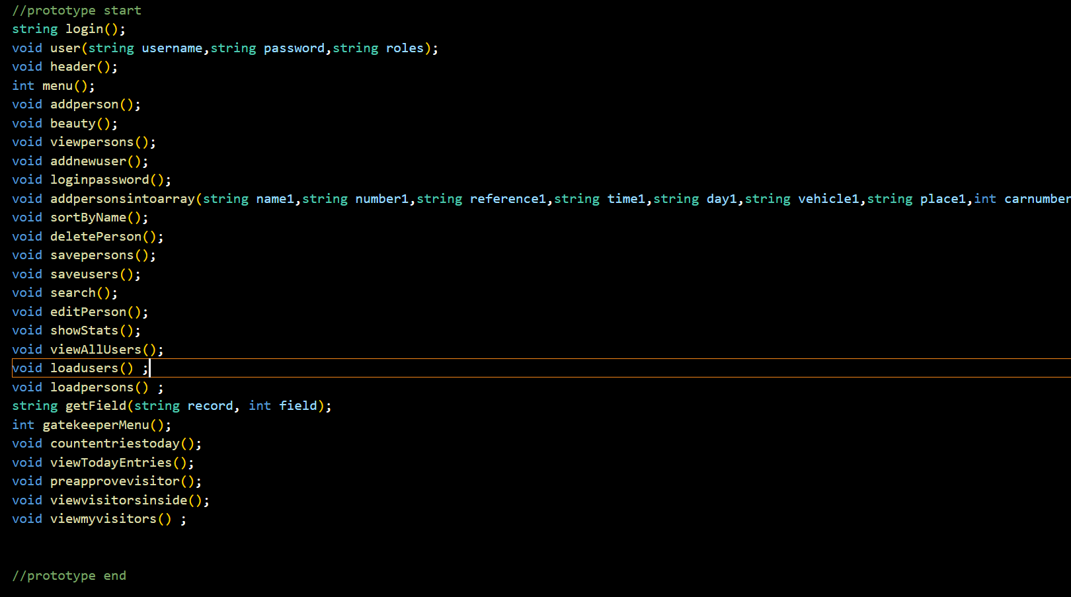

2.Function prototype

**FUNCTION WORKING FLOW:**

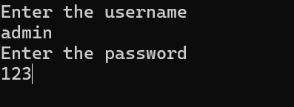

1.login

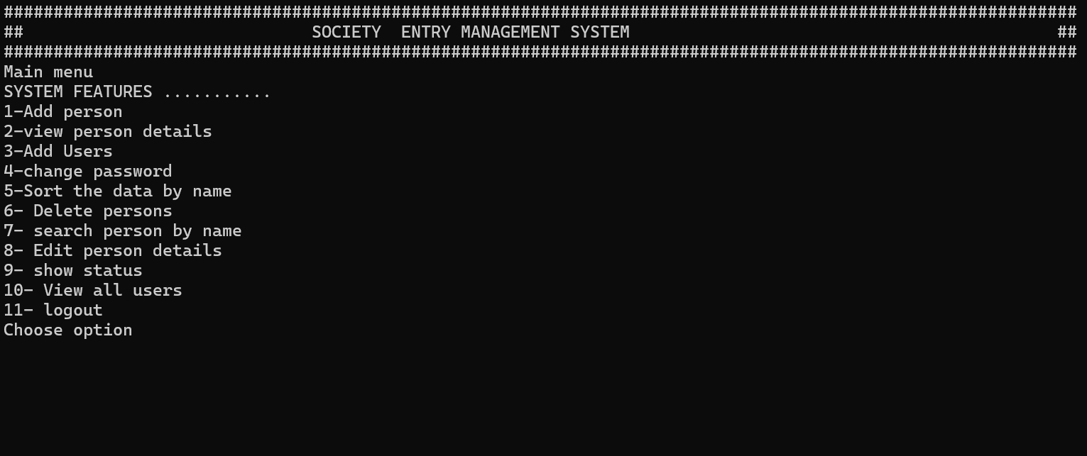

2.Admin menu

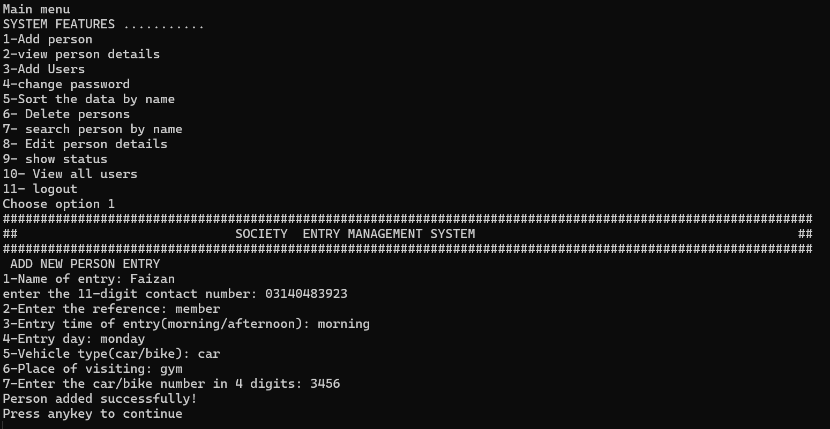

3.Add person detail

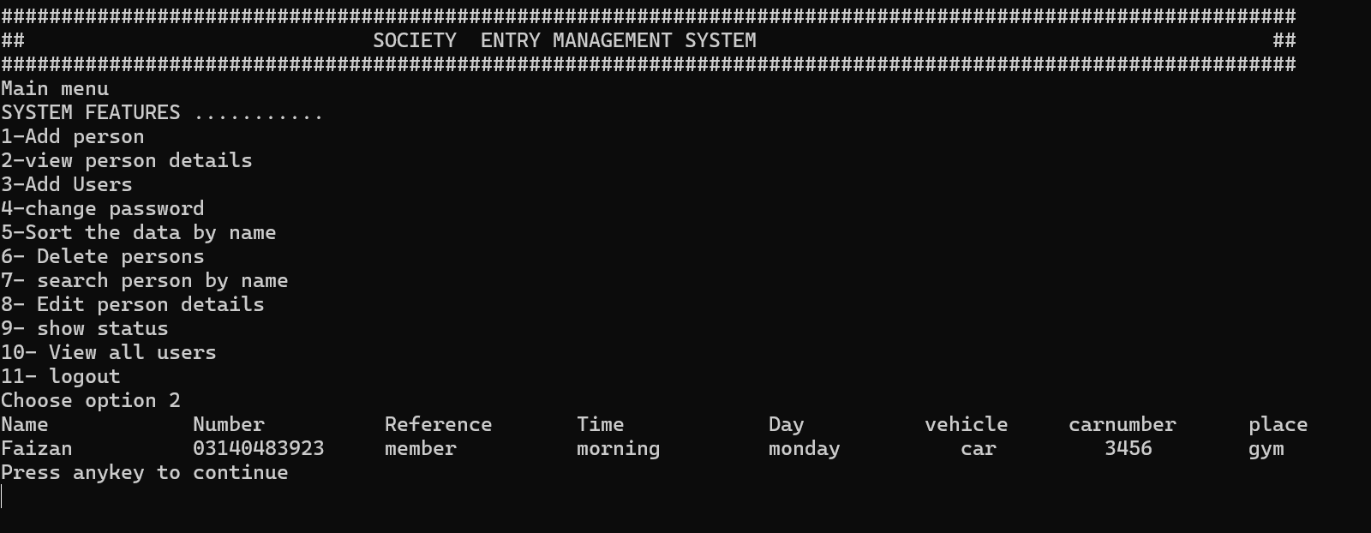

3.View person detail

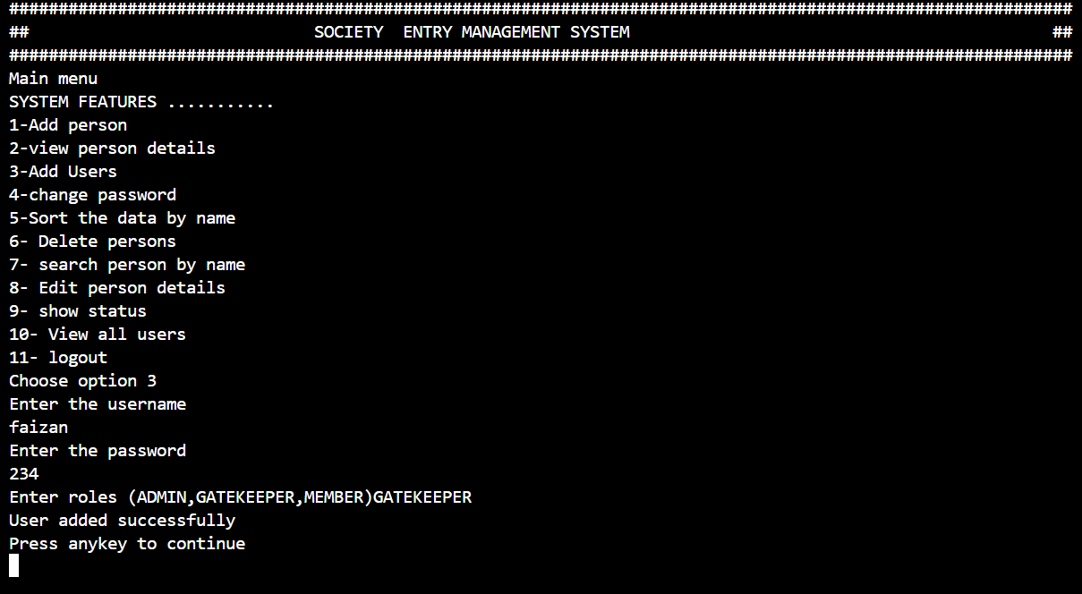

4.Add user

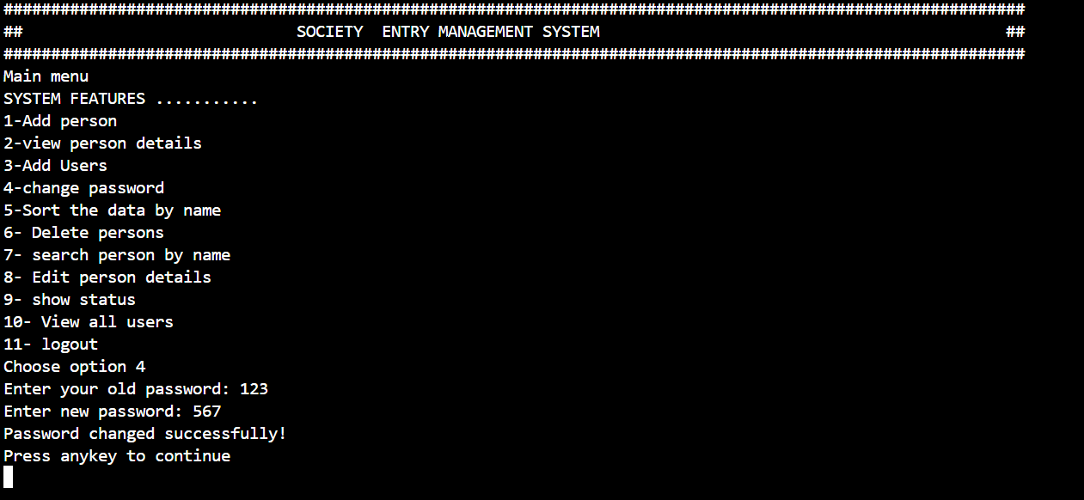

5.Change password

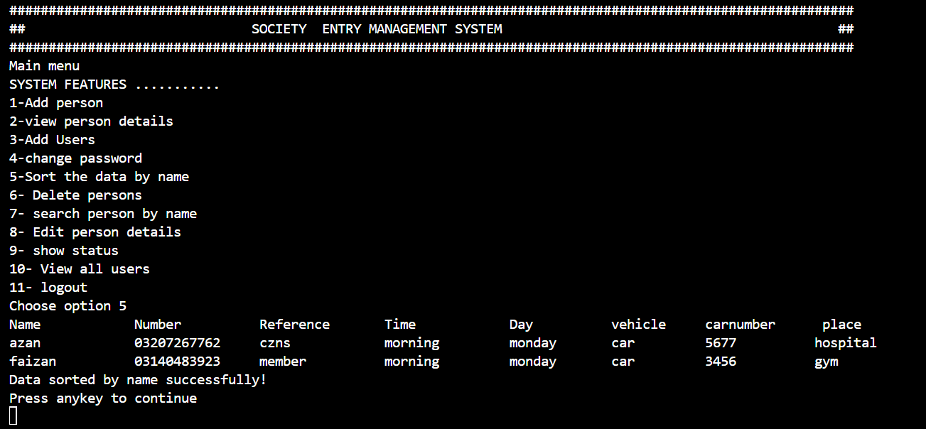

6.sorting the data by name

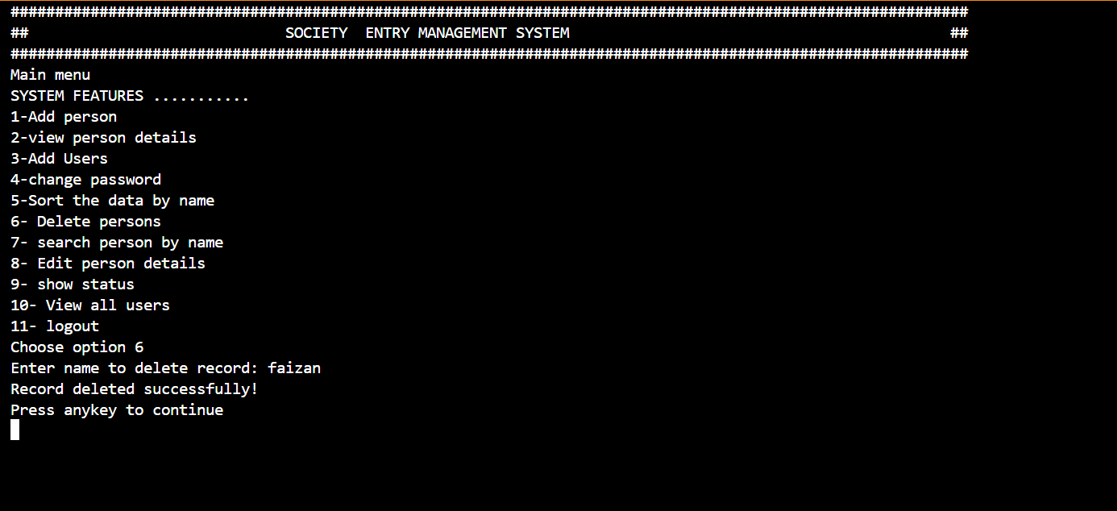

7.Delete the data

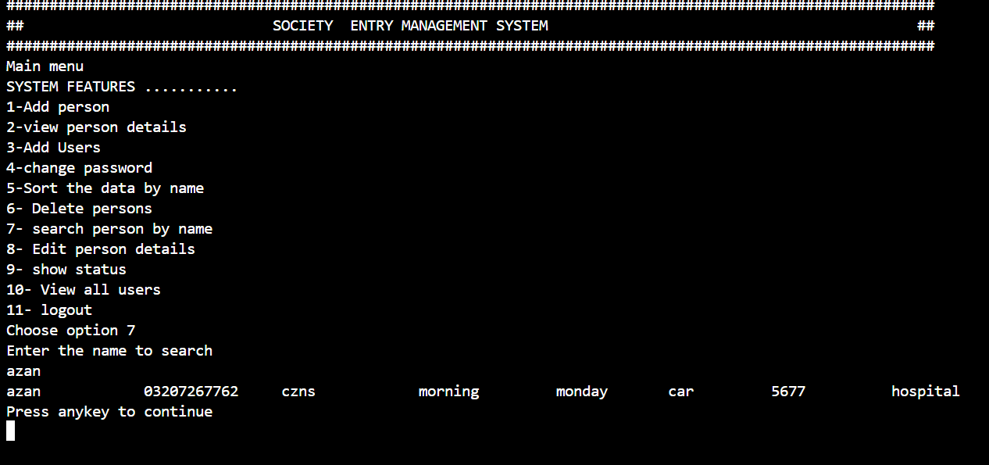

8.search the data

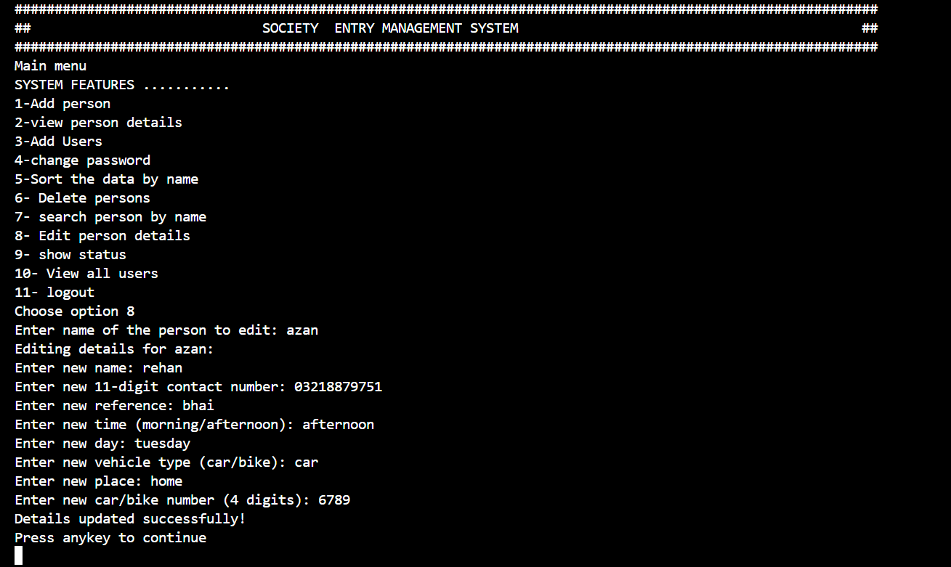

9.Edit person details

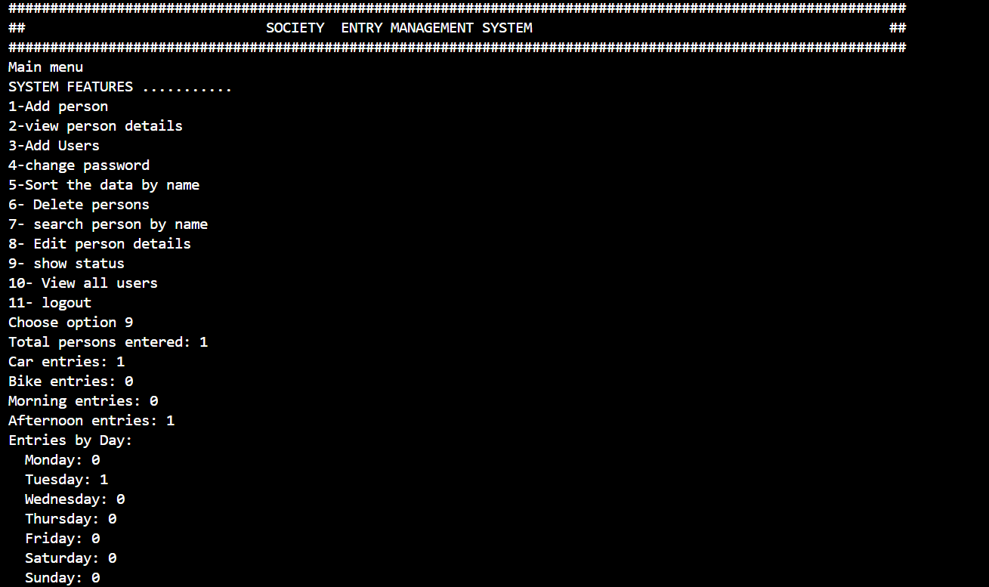

10.Check the status

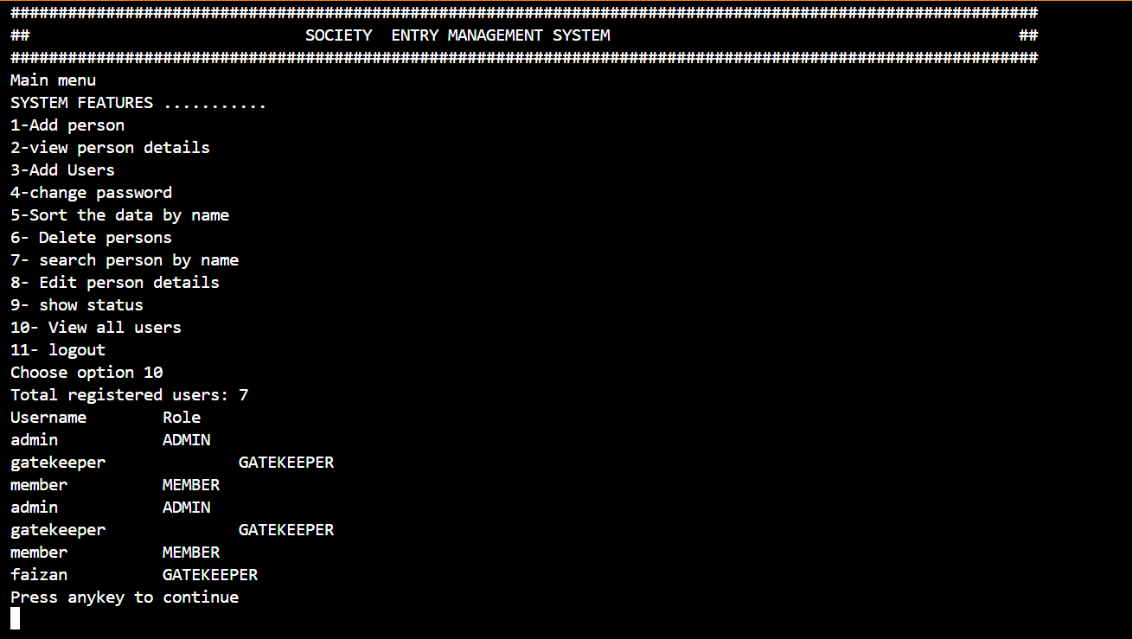

11.View all users

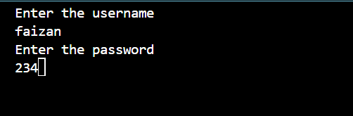

12.after logout

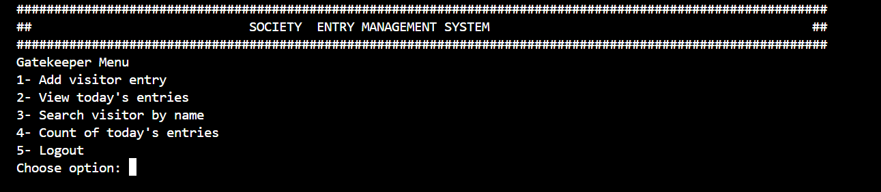

13.Gatekeeper menu

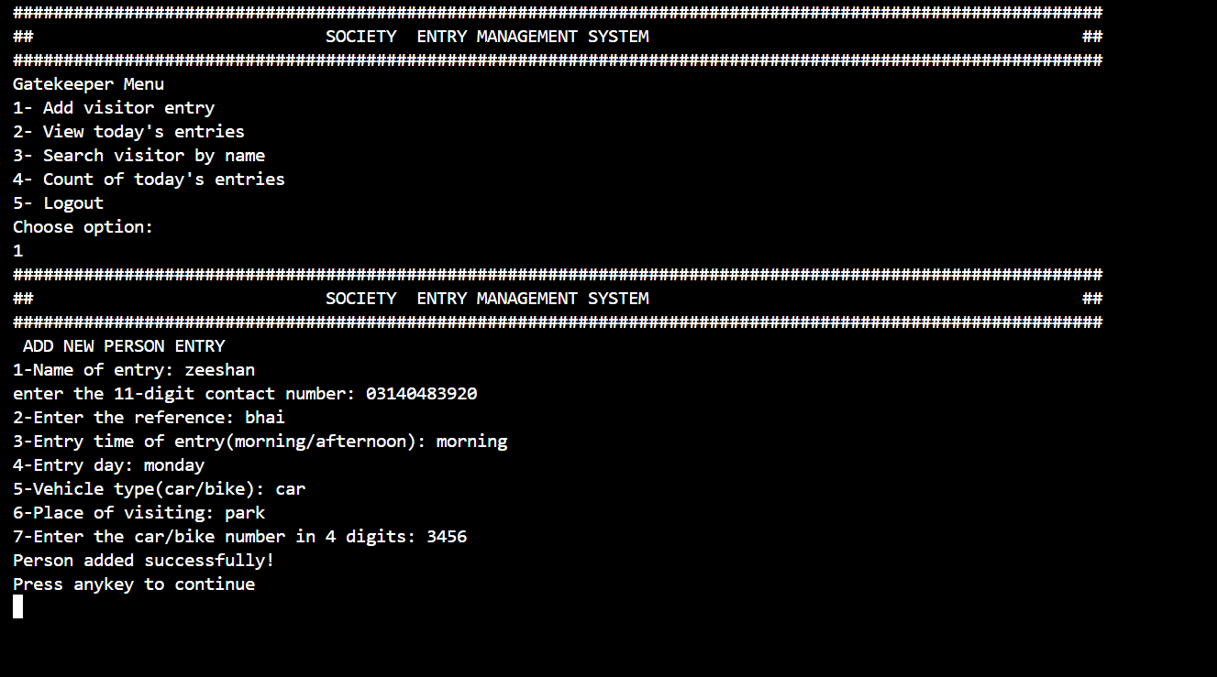

14.Add person

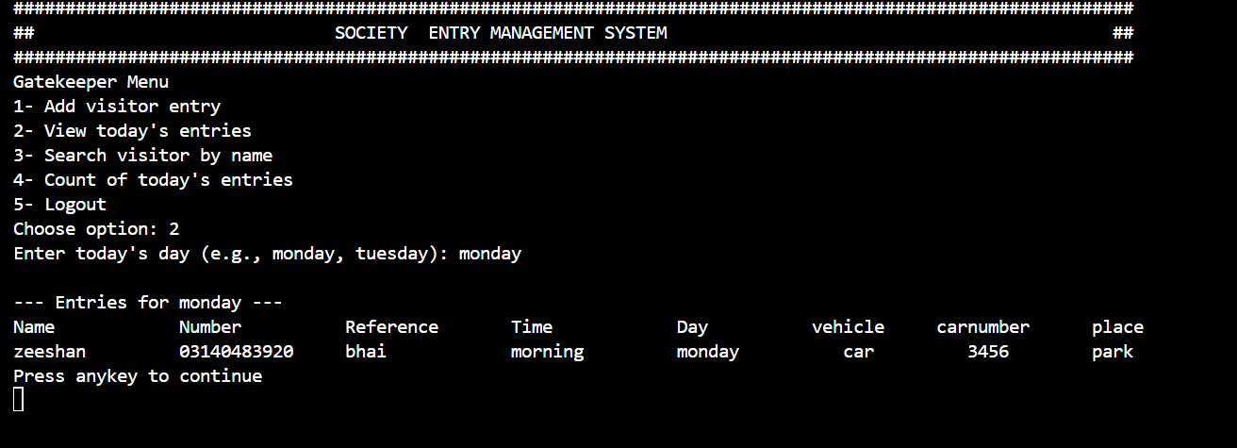

15.View entries by day

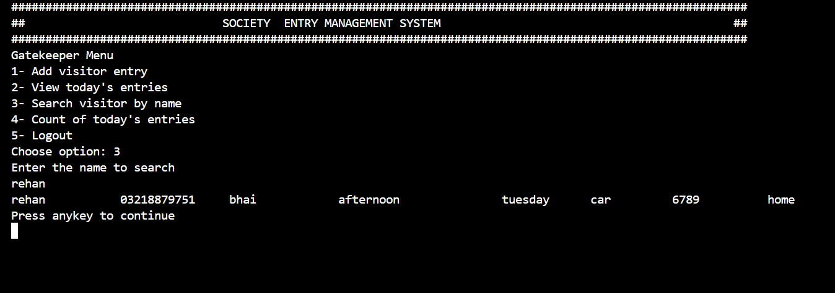

16.search data by name

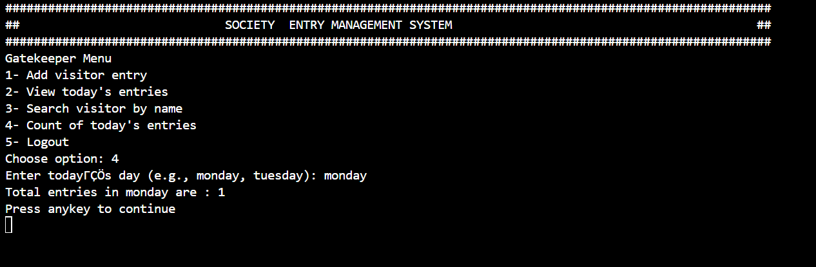

17.Count the entries

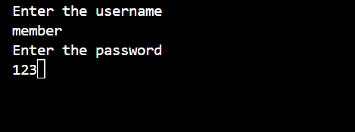

18.After logout

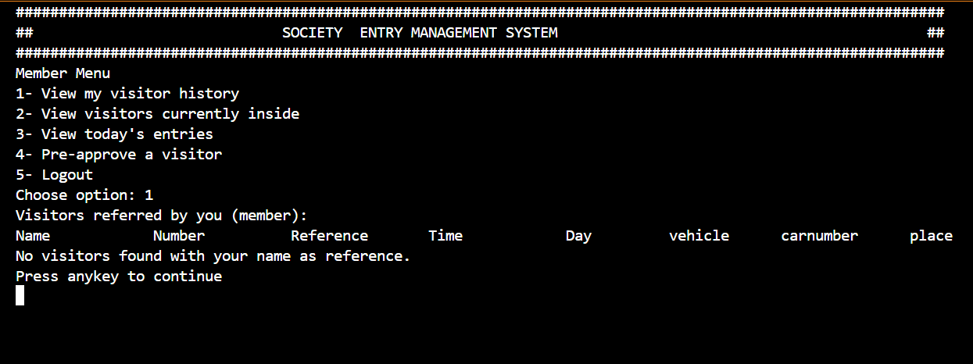

19.view your history

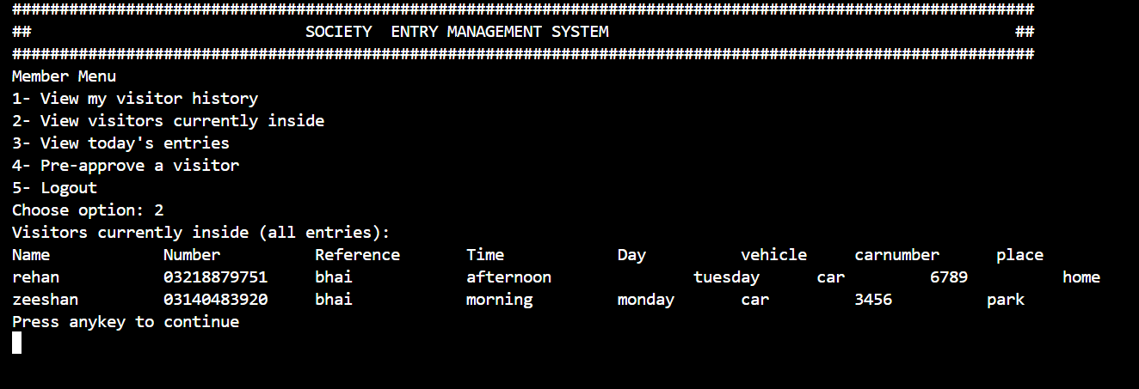

20.View visitor inside

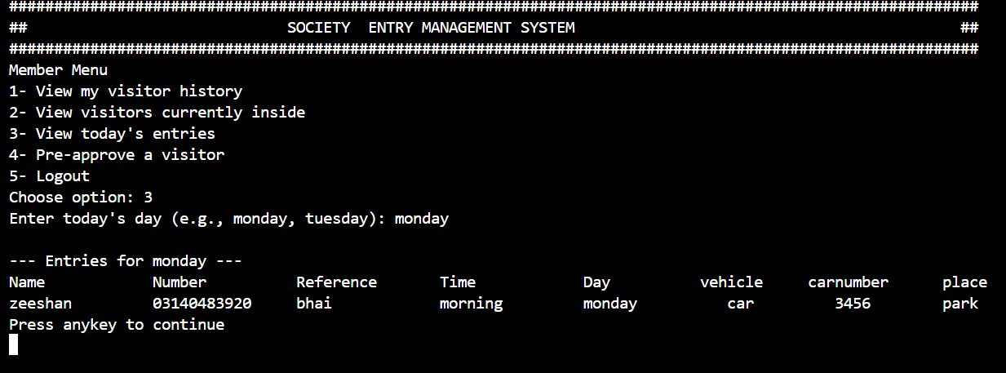

21.View today’s entries

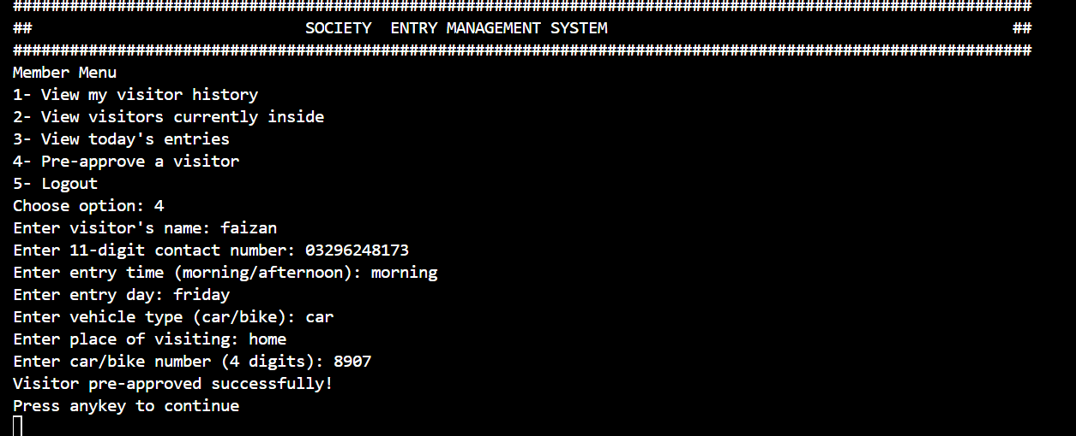

22.Pre approved the visitor

**FLOWCHART OF SEMS**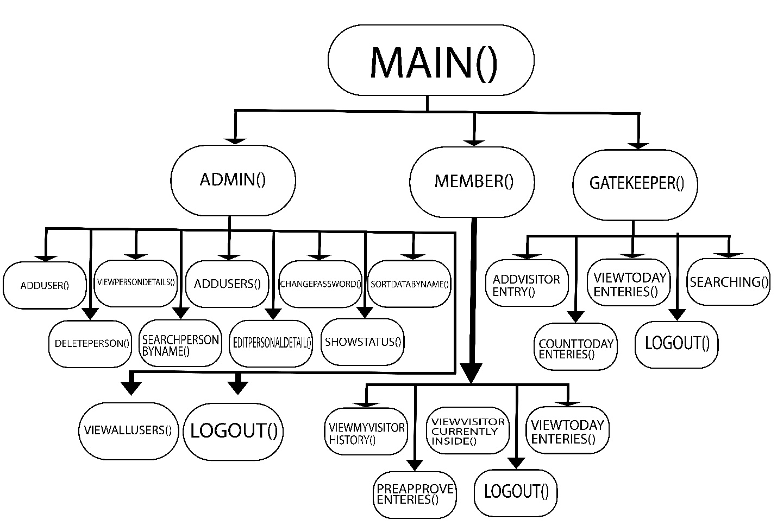

**FUTURE DEVELOPMENT:**

My program currently lacks a centralized database, limiting data access to individual users. Future development could include integrating a database to enable real-time data sharing and synchronization across all users.

**WEAKNESS:**My program requires manual time entry, but future enhancements could include integrating with a real-time clock to automate timestamping and improve efficiency.

**CONCLUSION:**The Society Entry Management System is a complete and functional solution for small to medium-sized residential communities. With features tailored for different user roles, it provides ease of use, data security, and efficient management of visitor information.

**RUBRICS:**

|  |  |  |
| --- | --- | --- |
|  | **A-Extensive Evidence** | **DONE OR NOT DONE** |
| Documentation Formatting **Grade:** | All the documentation meets all the criteria. | Done |
| Documentation Contents  **Grade:** | Documentation includes all of the criteria. | Done |
| Project Complexity  **Grade:** | Project has at least 2 user’s types and each user has at least 5 functionalities. | Done |
| Code Style  **Grade:** | All Code style criteria is followed | Done |
| Code Documentation Mapping  **Grade:** | Code and documentation is synchronized. | Done |
| Data Structure (Arrays)  **Grade:** | Data structure is sufficient for the project requirements | Done |
| Sorting Features  **Grade:** | Sort working 100% and generating useful report | Done |
| Modularity  **Grade:** | Meet all Modularity criteria | Done |
| Validations  **Grade:** | Validations on all number type inputs are applied | Done |
| Recommendation Feature | Proper meaning full recommendation is present into system | Done |
| Presentation and Demo  **Grade:** | Presentation and Demo was 100% working | Done |
| Student Understanding with the Code.  **Grade:** | Student has complete understanding how the code is working and knows the concept. | Done |

|  |  |
| --- | --- |
| **Checked by:** | Click or tap here to enter text. |